**Ethernet – Different Ethernet Standards (some)**

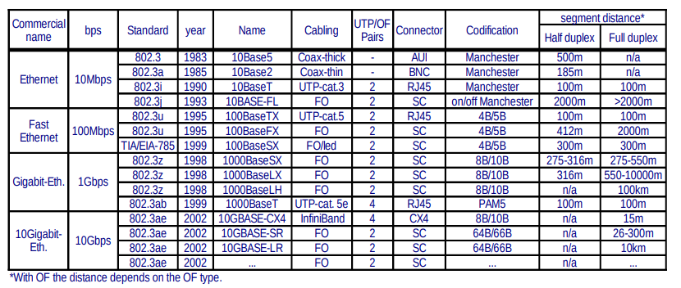

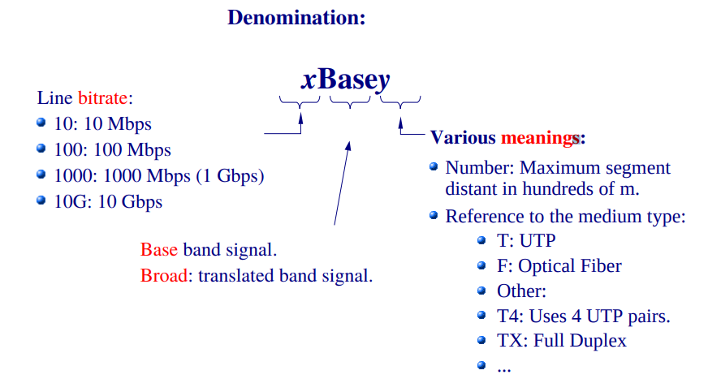

10BaseT:

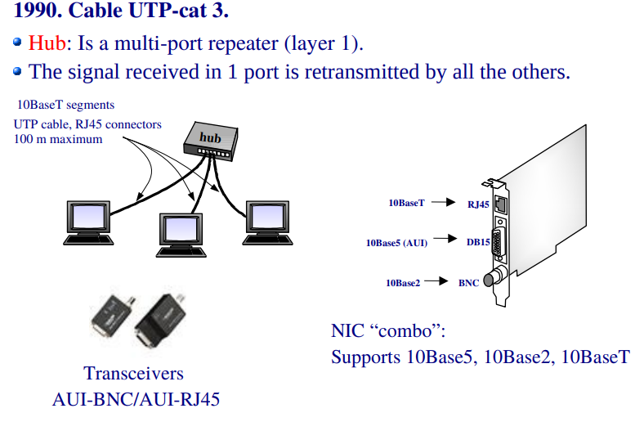

After 10BaseT:

All standards use UTP o OF (except 10GBaseCX4):

* Fast Ethernet (1995). 100BaseTX: UTP-cat. 5.
* Gigabit Ethernet (1998). 1000BaseT: UTP-cat 5e.
* 10Gigabit Ethernet (2002). Uses optical fiber. The only copper standard is InfiniBand with segment size ≤ 15m.